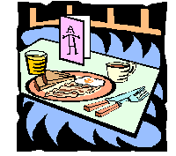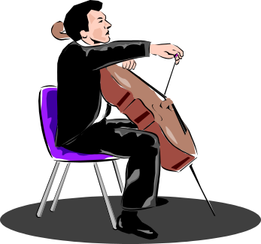
BENEFIT BRUNCH FOR AUTISM
Sunday, November 15, 2015 – 11:30 AM – 2 PM
Villa Marconi Centre - 1026 Baseline Road
(Corner of Baseline Road & Farlane Boulevard)
**SILENT AUCTION OPENS AT 11:30 AM**
Tickets are $30 Adults, $15 Children ages 5-12 (under 5 free)
- Children at Risk -741-8255
Enjoy a superb Brunch, listen to the soothing sounds of
KDS Scholarship Recipient Christine Bourgeois
& shop our Auction for holiday gifts!

We are also delighted to welcome back Lauren & Ben, students from the
National Capital Suzuki School of Music!

MASTER OF CEREMONIES: PATRICIA BOAL, CTV OTTAWA NEWS
Organized by The King’s Daughters and Sons to raise funds for
Children at Risk and Autism Supports in the Ottawa Area.
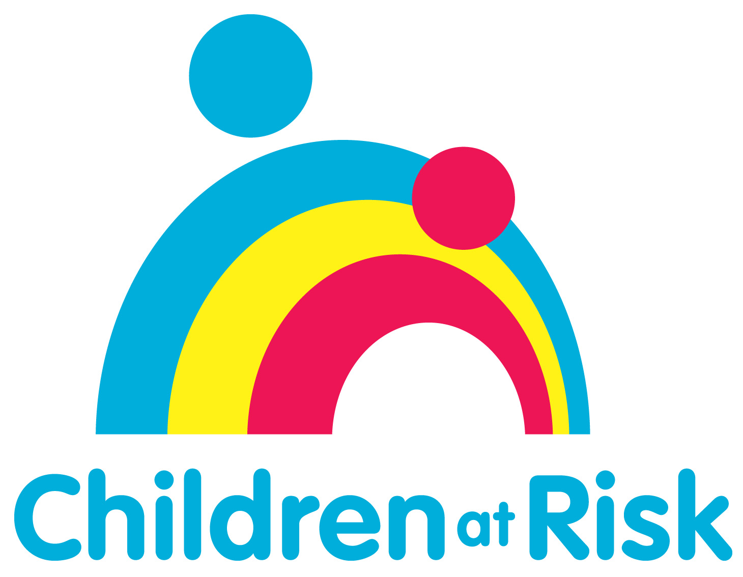 , Ottawa  www.childrenatrisk.ca | 

