THE ANNUAL GENERAL MEETING OF

NEWSLETTER
JUNE 2015
Issue #71
235 Donald Street, Suite 209
Ottawa, Ontario K1K 1N1
Tel: (613) 741-8255
Fax: (613) 741-5530
Email: car@childrenatrisk.ca
Web: www.childrenatrisk.ca
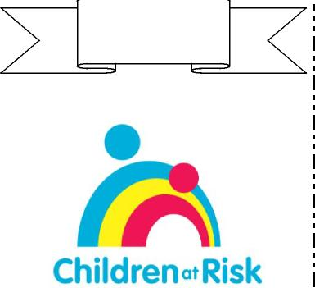
36 Years of
Service
1979-2015
CHILDREN AT RISK, OTTAWA
Wednesday, June 10, 2015
235 Donald Street, Room 209 – 7 p.m.
You are invited to attend the Annual General Meeting of Children at Risk. This evening will also be an opportunity for all friends and families of Children at Risk to meet informally and to discuss issues around supporting children and families within the Autism Spectrum Disorders. Wine and cheese will be served!
**Special Guest Speaker**
Lisa Whittleton, BSc. is a Financial Advisor who has a strong interest in
helping families raising children with disabilities. She has researched the
information surrounding the Registered Disabilities Plan and can help a
family navigate and facilitate the very complex and specific rules. Lisa
regularly presents to other family groups, organizations and professionals.
She is also the Winner of the 2014 Financial Services Person of the Year
with the Orleans Chamber of Commerce Business Excellence Awards.
Lisa can be contacted at Lisa.Whittleton@freedom55financial.com
The following business will be conducted: 1. Minutes of 2014 AGM
2. President’s Report 3.Treasurer’s Report & Appointment of Auditors 4. Fundraising Report 5. Election of new Board

Standing for re-election to the Board are: Lesia Gilbert * Mark Lalonde * Neil Dzuba * Michelle Thompson * Martha Perry

Charitable Registration #
10691/3775/RR/0001
MARK YOUR CALENDARS
Annual Spring Raffle June 2015
Ottawa Autism Community Annual Family Picnic Sunday, June 14, 2015
Ottawa Dragon Boat Festival June 25-28, 2015
LIVE 88.5 FM Golf Tournament Monday, July 27, 2015
Children at Risk Issue 71 Page 1
The following positions are vacant: Up to 2 Directors – if you are interested in getting involved with Children at Risk by becoming a Board Member or a Volunteer Executive, please contact our offices at 613-7418255 or email car@childrenatrisk.ca before the Board Meeting to register your interest and present a small bio.
The Children at Risk Board follows the Carver Policy Governance Model, now meeting bi-monthly to review charity policies and happenings. We are especially looking for Board Members who either have experience or background in Human Resources and can attend Board Meetings, but also those who have the ability and desire to help with Fundraising Events and Activities – specifically charity representation at such Events. Throughout the year Children at Risk either stages Fundraisers or is invited as a recipient charity and it is important for a Charity Representative to attend, be social and impart the cause of Autism and how Children at Risk provides supports for ASD children and their families!
Members who cannot attend may give a proxy to any other person, who need not be a member. Proxies must be in writing, signed by the member who will be absent, and mailed to or brought to the meeting by another member. Members who have given a proxy may still change their minds and attend, in which case the proxy is cancelled. Only those members who have paid their annual membership dues to Children at Risk, Ottawa, have the privilege of voting at the AGM. However, ALL are welcome to the AGM, even if you are not a Member!
By Order of the Board, Paul Lacroix, President, May 10, 2015

2014/2015 BOARD OF DIRECTORS
President – Paul Lacroix
Treasurer – Lesia Gilbert
Secretary – Mark Lalonde
Director – Natasha Ell Saunders
Director – Michelle Thompson
Director – Neil Dzuba
Director – Martha Perry

PRESIDENT'S MESSAGE
Paul Lacroix, Board President
It is with heavy heart that this will be my last President’s message. After many years as Board President, the time has come to pass the torch. As President you are only as good as your Board of Directors and together we have implemented a lot of changes and growth over the past years. So to each and every one of the Board Members over the years - we all owe you a BIG “thanks”. Mark Lalonde has been on the board as Secretary/Vice President for the past few years and has accepted the nomination to run for President. Working side by side all these years I has seen Mark’s passion and dedication for Children at Risk and have every confidence in the direction he and the Board will lead CAR. Please continue to support Mark as you all supported me. Having said all this, you will still see me at events and have offered to attend special functions as “Past President” if ever needed. This message would not be complete without speaking of Brenda and Bambina. There is not enough space in any newsletter anywhere on earth to ever cover the feelings, love, respect, appreciation and admiration that I have for both Brenda and Bambina. Their countless hours, dedication, passion and love beyond doubt make CAR the great charity that it is! From the late night Bingo’s of many years ago - to today’s Camp Kaleidoscope, CAR has come a long way!
Also many thanks to Natasha Ell Saunders for her 3 years of Service on the Children at Risk Board of Directors. Natasha has indicated her return to work full-time and managing her young family has her fully occupied. It was nice to have her as our resident “legal-eagle” for those years and we know we will still see her at CAR events and activities!
Love you all and thanks for the many great friendships and the many great years. I truly cherish them.
PAUL LACROIX
CHILDREN AT RISK BOARD PRESIDENT
Children at Risk Issue 71 Page 2
2006-2015
The name Paul is from the Roman family name Paulus, which meant "humble" in Latin. Saint Paul was an important leader of the early Christian church – in some ways this long-standing President of the Children at Risk Board of Directors was OUR Leader! Paul Lacroix led by example – from representing the Board at multiple functions to tirelessly volunteering at fundraising events and activities. Paul actually took over part of a term when our Board President was unexpectedly transferred from Ottawa – and never looked back! He was instrumental in helping the Board of Directors move to a Carver Model, deciding policy – not how many paper clips the office is allowed to buy each month! His terms covered a large period of change and growth for Children at Risk – from financials of $145,000 to almost $500,000 – from serving 128 children annually to serving 430 children. Paul recognized the critical lack of Services for higher-needs ASD children and supported making a 4-year Dream turn into Reality with the creation of a Summer Day Camp, Camp Kaleidoscope. With raising his higher needs ASD son, David, Paul knew how much need there was in our Community for Services like Camps and Respite Programs. His involvement became a family affair – with his wife Debbie our Camp Director for 3 years, as well as their son Daniel and daughter Rachel working and volunteering for the Charity. Without Paul’s leadership and direction, Children at Risk may not still be in existence, much less the Leader the Charity has become in the Ottawa Autism Community for “Filling In The Gaps” in Services and Supports!

Paul, thanks for all you do!
Children at Risk Issue 71 Page 3
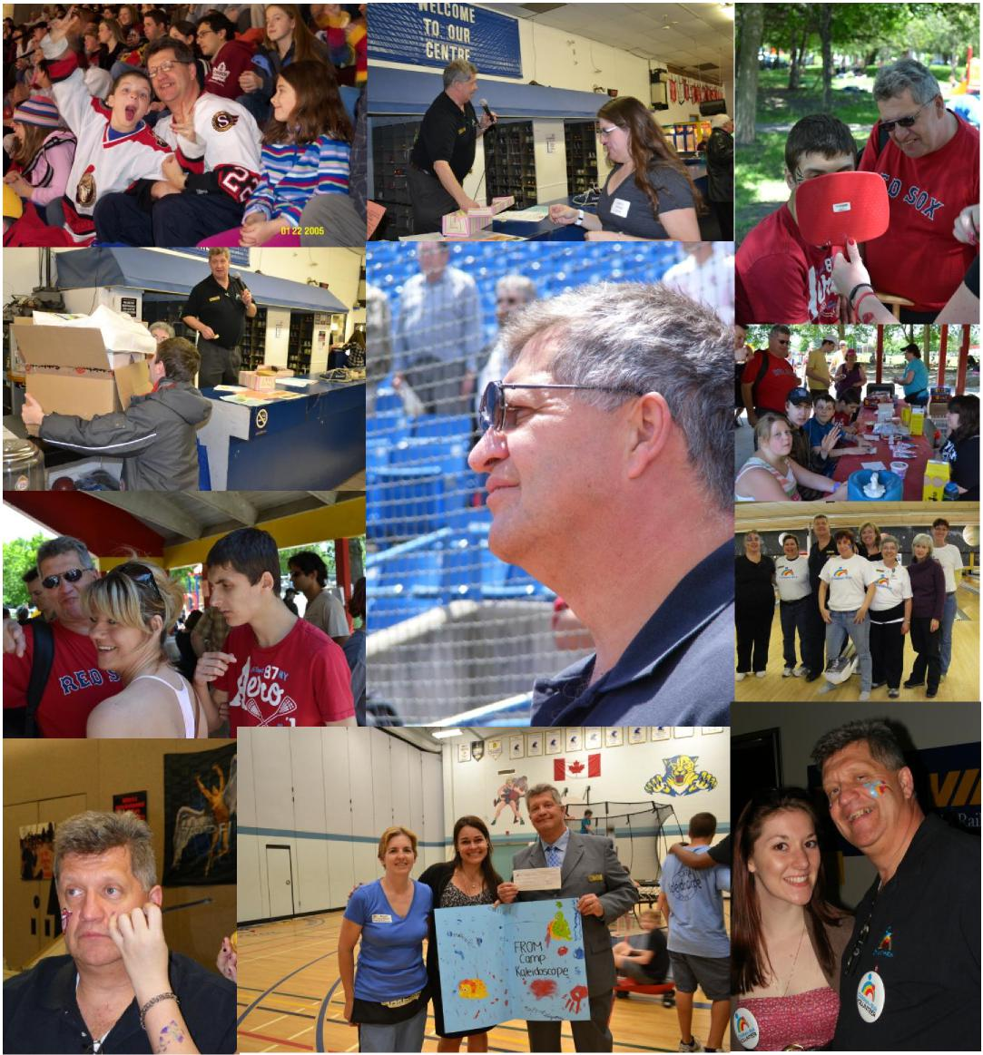

EXECUTIVE DIRECTOR’S MESSAGE
Children at Risk Issue 71 Page 4
As I write this, we are just a hair`s breath away from filling our final Camper Spots for our 2015 summer day camp, Camp Kaleidoscope ... we are looking at 275 weekly camp spots, over 110 Families! Our Office and Camp Staff have been very busy sorting out the administrative and scheduling labyrinth that is Camp (see Camp article Pages 13-16) – while still operating Saturday Fun Clubs, Family Fun Nights – and Fundraisers to finance these Services and
Supports!! We had excellent news that the
Community Foundation of Ottawa once again has
recognized the value of
our Services by a recent
grant of $10,000 towards
the support of higher-
needs Campers that require more than a 1:1 support at Camp for their needs as well as providing for both their and other Campers safety. June is hopping – with our AGM June 10, the Annual Family Picnic on June 14, the Dragon Boat Festival on June 25-28 ... then Camp starting on July 13 - WHEW! Wishing everyone a safe, warm and restful summer!
FUNDRAISING UPDATE
Submitted by Brenda Reisch, Fundraising Chairperson
EVENTS/ACTIVITIES SINCE MARCH 2015 ...
1st ANNUAL “WALKIN’ & ROCKIN’ FOR RISK”
Sunday, April 26 dawned somewhat grey and cool – fortunately by the afternoon, the sun was peaking out and helped to make our 1st Annual Fundraising Walk a great success! “Walkin’ & Rockin’ for Risk” kicked off at 1 PM with a welcome message by Honourary Walk Chair, Nepean-Carleton MPP Lisa MacLeod, introduced by MC “Eric the Intern” from CHEZ 106.1 FM. Our Live Band “RPM” got everyone in the mood with great music, as our Walkers rounded the circuit located at the back of our building on Donald Street.
Families got to taste their first BBQ of the season,
expertly cooked by Enbridge Gas Distribution,
peruse and bid on items at the Silent Auction, as well as have fun on the big Inflatable Slide and Moon Bounce.
Stellar face painting was provided by Heather from A Little Bit of Bling and the Capital City Garrison joined us with Darth Vader, Storm & Snow Troopers and Imperial Officers! Walkers got to enter draws for the “Pick-A-Prize” walk rewards and shop the Market Place with Vendors like Pampered Chef, Epicure and social enterprise Family Harmonies Familiales. Top Pledge prizing was earned by the Russell Family, while the Brown and Lam families tied for 2nd and 3rd Place! All the Pledges and Activities raised just shy of $3,000 for Children at Risk! We can hardly wait until next year!!
“Dear CAR families, Sunday, April 26 was a very memorable day for my son Anuk and for me. When the clock struck 1 pm, the wind died down and the sun began to shine for CAR's 1st Annual "Walkin' & Rockin' for Risk". In other words, for our children! Music filled the air in a beautiful, safe, outdoor area. I felt comfortable with Anuk running off to get his own hot dogs because he was surrounded by counselors and volunteers who know him from Camp Kaleidoscope and Spring Break Camp. And those hot dogs were delicious! He met his father Darth Vader, and he danced with a Stormtrooper.
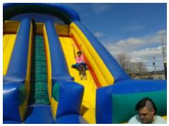
He pretty much had the inflatables to himself. He went down the large slide
countless times. The one thing
missing was more friends to share all the happiness! If CAR is able to do
this again next year, I hope you come out and join the fun!” Asha CAR parent & Anuk CAR Camp Kaleidoscope Camper
“We had fun yesterday and Congratulations on your whole set up! The sun finally came out..yeah! The walk was fun, made it around 9 times, throughout the afternoon. Dancing was great, and Brenda, glad you could enjoy some time away from business! Hope the other staff could as well. We hope you had a good turnout and made some money!! One could see that everyone made quite the effort and the band was great. My back a bit sore from that activity, but wonderful day.
Alex was able to go on the slides as well, he loved that. So thanks ever so much for the pleasant day!” Beth & Alexander

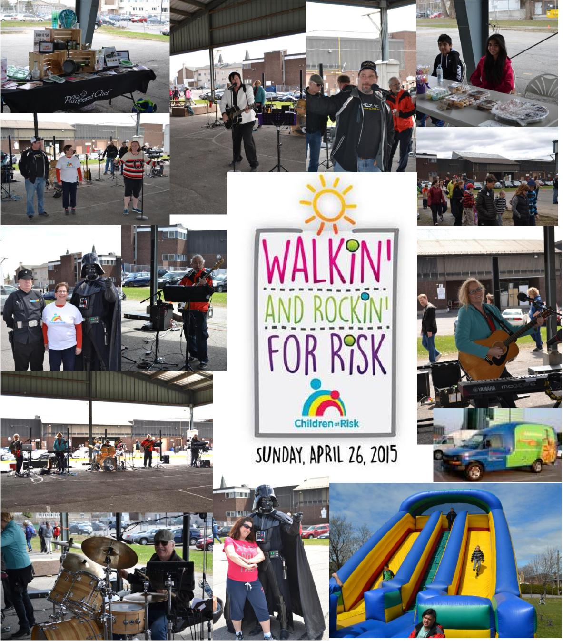
Children at Risk Issue 71 Page 5

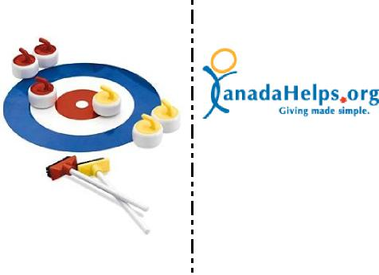
KIWANIS CLUB OF RIDEAU ENDOWMENT FUND DONATION
Once again our long-term relationship with the Rideau Kiwanis Club was again strengthened by a generous donation to our Fundraising Walk of $630! For several years, these community-minded Kiwanis Members have donated funds and volunteered for Children at Risk fundraising Events and Activities, like our Pumpkins and Raffles! For this continued and generous support – recognizing that Autism is not something that can be fixed with a one-time donation – we award the June 2015 Newsletter “Hat’s Off” to the Kiwanis Club of Rideau!
DONOR SPOTLIGHT
In April, Children at Risk was delighted to be chosen by the Canada Revenue Agency Information Technology Branch to receive funds raised by their CRA-ITB Employee Curling Tournament.
This enthusiastic group “hit the rocks” for this fun, annual event – and asked for Donations, as well as Prize Draws with the Tournament and raised a very welcome $725 for Children at Risk!!
Many thanks for the efforts of ITB Staff, especially to parent Luc Vienneau for putting forth our Charity as recipient this year!
DONATE A CAR CANADA
Donate A Car Canada accepts
Children at Risk Issue 71 Page 6
vehicle donations for
Children at Risk Ottawa to donate a car, truck, RV, boat, motorcycle or other vehicle to CAR simply fill out the DONATE NOW tab at www.donatecar.ca. Donate A Car Canada can provide you with free towing in many areas across Canada. Donate a Car Canada can pick up your car or truck, or you can drop off your vehicle to maximize your donation. When you donate your car it will either be recycled or sold at auction depending on its condition, age and location. Donate A Car Canada will look after everything to make your donation easy for you to support Children At Risk Ottawa. DONATE NOW at www.donatecar.ca and CAR will send you a tax receipt after your car donation is complete!
Since March, Children at Risk received $100 from supporters donating the proceeds of their old vehicles. Participants since November 2012, funds raised by Donate A Car have reached $14, 638.43! Note that you do not have to live in Ottawa to participate – it is across Canada – so encourage friends and relatives out-of-town to participate, as well!
CANADA HELPS
Children at Risk has signed up with CanadaHelps.org. When you visit our Website at www.childrenatrisk.ca just click the Donate Now button and you will be linked to the CanadaHelps.org donate page for Children at Risk. As with any service, there are some administration charges, but this allows anyone to donate on-line and even anonymously, if desired. It allows 24 hour ability to direct a donation to our charity and the electronic ease that many of us are looking for to support charitable causes!
All you have to remember is our website – childrenatrisk.ca and the rest is easy!! $72.08 donated through Canada Helps April to May!

WHAT IS ON NOW/COMING:
Children at Risk Issue 71 Page 7

LiVE 88.5 Ottawa’s Alternative Golf Tournament

Location: RideauView Golf Club| 6044 Rideau Valley Drive North
Date: Monday, July 27th, 2015 |Cost: $1200/foursome (+HST)
Registration: 11:00am | Lunch: 12:00pm |Shot gun: 1:00pm sharp | Dinner: 6:00pm
We’ve got Ottawa’s premiere private golf course: Rideau View Golf Club. Unless you’re a
member, a Golf Pro or you were in the LiVE Alternative Golf tournament last year, you’ve
probably never played THIS top ranked course before.
RideauView is a private golf club and arguably the region’s finest course. It features a spectacular
golf experience on a championship course with beautiful facilities in a serene, rural setting.
We can help you out Monday July 27th we are bringing the Alternative Golf Tournament!
Rideau View. Your foursome is twelve hundred dollars with proceeds going to
CHILDREN AT RISK.
Your day will begin with a buffet lunch before you hit the links. You’ll spend the day on Ottawa’s
premier private golf course - RideauView, with 18 holes of golf including power cart. Enjoy the
finest food and spirits, enjoy live entertainment, win amazing prizes and end the day with an
informal cocktail style dinner.
No sit-down dinner. No speeches. Guaranteed.
Go to www.live885.com – Click on Events at the top and scroll to the Golf Tournament to Register!

ENTERTAINMENT GOES DIGITAL!
Support Children at Risk’s
newest Entertainment®
fundraiser this spring! For $20 you will receive a
mobile and online
membership that gives you savings in Ottawa and in over 100 different North American cities.
With 1 membership you can save on your mobile phone or print offers online at Ottawa restaurants like Broadway Bar & Grill, Arby’s, Social, New York Fries, Domino’s Pizza, Giovanni’s, Mr. B’s, Izakaya Asian Kitchen and more. Exciting family attractions include: Altitude Gym (Clip & Climb), Kids Kingdom, Fun Junction, Fun Haven, Agriculture Museum, Carleton Athletics and more! Other types of savings include oil changing, framing stores, dry-cleaning and more!
As an added bonus the GPS on your phone will access savings when you travel. If you travel to Kingston, across the border to New York State or venture to major cities such as Montreal, Toronto, Calgary or
Orlando, there are many savings available. An
example, in Toronto you could save at The Hockey Hall of Fame and in Calgary you could save at the Calgary Zoo.
Contact Brenda or the Office at Children at Risk. Make your $20 payment and pick up your membership at the office or it can be emailed to you. Go to entertainment.com/get started and follow the simple instructions to activate your membership. Some offers are available mobile, so you can scan and save at a merchant and you can print offers online.
This is the perfect membership in the months leading to summer vacations. For only $20 you will support Children at Risk, and you will save money!
DONOR’S CORNER
The Ottawa Jewish Community Foundation (Anne Blair and Hyman Mayberger
Endowment Fund) $141
Dinosaur Fiesta Abilities Dance $140
4TH ANNUAL ORLEANS AMATEUR BBQ CHAMPIONSHIPS – SATURDAY, JUNE 13
Sponsored by Romantic Fireplaces & BBQ’s in Orleans, the BBQ Championship event features local teams. Come visit our champion BBQ teams on Saturday, June 13th as they vie for prizes and bragging rights in the Orleans Amateur BBQ Championships.
Children at Risk Issue 71 Page 8
The Orleans Amateur BBQ Championship is sanctioned by the Canadian Southern BBQ Association to help promote "Grilling Smoking and BBQ Across Canada". Cooking starts early in the morning with judging from Noon to 1 PM, winners announce at 2 PM. Bring the Family from 10 am to 3 PM to see BBQ charcoal demos, as well gas grill demos and tasty samples! There will be a bouncy castle and face painting to support Children at Risk.
For more info or event to enter your BBQ Team, visit
http://www.csbbqa.com/Romantic/index.html
5929 Jeanne D'Arc Blvd
Ottawa (Orleans), Ontario K1C 6V8
SUMMER GARAGE SALE
For those who are looking to do some Spring and Summer cleaning and purging – PLEASE keep Children at Risk in mind! Early August we will again hold our Annual Garage Sale at our summer camp at Lester B. Pearson High school on Ogilvy. However, as we have access to storage space, we can start accepting donations on July 13! So save your unused and previously-loved items for Children at Risk – and help raise funds for Camp Kaleidoscope!!

Children at Risk is delighted to be 1 of the 5 Recipient Charities for 2014 & 2015!

June 25-28, 2015
Children at Risk Issue 71 Page 9
Each charity has requirements to fulfill to receive their funds – as well as help raise funds for the Dragon Boat Foundation!! The Following are activities we are responsible for:
- Providing Volunteers – our charity is required to provide 200 hours of Volunteer time – most shifts are 4 hours each – but Volunteers can choose how much they can give! There is an on-line Volunteer Sign-Up –and Volunteers can choose from dozens of assignment areas and times – from set-up to Festival duties to tear-down – whatever works for your schedule! Just make sure to credit Children at Risk when you sign up!! www.dragonboat.net/volunteer.aspx
- Raffle Tickets – The Ottawa Dragon Boat Foundation now has available Raffle tickets at $10 each. Each Dragon Boat Charity has been asked to sell tickets as part of our involvement. Call or email CAR to get yours today!
The Prizes are:
1ST PRIZE: TRIP FOR 2 TO NEW YORK CITY (RETURN AIRFARE FROM OTTAWA TO NEW YORK CITY & 3 NIGHTS IN A 4-5 STAR HOTEL) - $2500 VALUE
2ND PRIZE: TRIP FOR 2 TO LAS VEGAS (RETURN AIRFARE FROM OTTAWA TO LAS VEGAS & 3 NIGHTS IN A 4-4.5 STAR HOTEL) - $1500 VALUE
3RD PRIZE: OTTAWA “STAY-CATION” (2 NIGHT STAY RADISSON HOTEL OTTAWA,
ROYALTY LIMOUSINE TO/FROM HOME & $100 GIFT CERTIFICATE FOR ROYAL OAK) - $900 VALUE
- Silent Auction – Children at Risk is in charge of running the Silent Auction. All the charities involved are required to provide prizes, as well as the Foundation solicits prizes too...let us know if you can help in that area with donations!
- Dragon Boat Team – Children at Risk is entering Dragon Boat Team – already named the ̏Risk Riders̏!! Thanks to an overwhelming response – we are FULL – come down to Mooney’s Bay on June 27 to cheer on our Team!! If you want to donate a Pledge for our Boat - Dragon Boat provides a convenient, secure on-line ability to pledge with these links:
- To Choose a Risk Rider Paddler to Support:
https://ers.snapuptickets.com/ers/online-registration-landing.cfm?event=1101&lan=eng
- To Donate to the Risk Rider Team:
https://ers.snapuptickets.com/ers/online-registration-custom-page.cfm?event=1101
Select Risk Riders under pull down and click on Donate To A Team - Electronic receipts are issued automatically for donations of $20 or more made through the online donation system (and by request for donations under $20). Pledge form donations of $20 or more must include the donor’s name and a complete mailing address so that we can provide them a receipt by mail.
OR A donation can be made to Children at Risk to offset the cost of our Boat by calling 613-741-8255 or through our Canada Helps linkhttp://www.canadahelps.org/CharityProfilePage.aspx?CharityID=d2790 to get an electronic receipt!
Children at Risk will receive $25,000 (or more!) for 2014 & 2015 to support our Summer Day Camp,
Camp Kaleidoscope!

20th ANNUAL SPRING RAFFLE
Tickets are NOW available for our 20th Annual Fundraising Raffle! After many weeks of gathering quality prizes, we can proudly offer them for sale. (see Sample Ticket page 19) The prizes are fabulous! As we are getting started somewhat late ... we will need LOTS of help to sell out of our 6,500 tickets before the draw on June 14th! I hope everyone can join me in trying to make this year a sell-out!! Unsold tickets represent lost Fundraising $'s for Children at Risk. Funds raised will support our Community-
Based Special Projects. These include Sibling,
Friendship and Family Support Groups, Summer Camp, Educational Training Workshops and Information Seminars as well as updating resource
materials. These valuable activities receive no
government funding and are supported solely through Fundraising efforts and Donations.
*Note: Tickets can only be sold to persons 18 years and older! The Raffle will be drawn at 2 PM our Autism Community Annual Family Picnic – Sunday, June 14, 2014.
Our Raffle offers:
- Tickets $2 each, 3 for $5 or a book of 12 for $20!
- Prizes worth a total of $9,997!
- 28 draws, with an average Prize Value of almost $357 (Over half of prizes over $300 each!)
- Maximum 6,500 tickets sold - That's just over a 1 in 232 chance of winning!
- Minimum Prize Value of $25!
LOOK AT OUR 1ST FIVE PRIZES:
1st Prize – ALL ABOARD TO QUEBEC CITY! VIA Rail, For 4 to Historic Quebec City, Quebec -VALUE $1,492
2nd - SPRING CLEANING – 1800-Got Junk, Molnar Painting, European Glass/Paint, Jill Alexander – VALUE $950
3rd – TORONTO TRIP–Towneplace Suites Hotel, AVIS, Hockey Hall Fame, CN Tower, Swiss Chalet - VALUE $848
4th – Urban Element & Epicure Extravaganza - VALUE $565
20th ANNUAL SPRING RAFFLE Photo of a couple of the prizes ...
Prize #2
Prize #5 - Handcrafted Quilt
Jill Alexander Original
THANK YOU'S
Many Thanks to the Ottawa 67’s Hockey Team and the Ottawa Sports and Entertainment Group! On the last home game for the 2014/2015 Season, 3 Families from Children at Risk were invited to attend the game –
with the special bonus of their child receiving a game-worn, autographed jersey of a 67’s Player – along with meeting the Player and high-fiving the Team as they took to the ice for the Game! Pictured here is Bode receiving his jersey and enjoying the game with Mascot “Riley”!
“We were fortunate to receive tickets to a SENATORS game before the playoffs began and it was a great evening and fun to be part of the crowd cheering our team on. It was last minute but we dropped everything to rush over and take advantage of the opportunity. The support of families like ours is much appreciated. ” Ena, Jack and Jon

5th – HANDCRAFTED QUILT - VALUE $500
Children at Risk Issue 71 Page 10

FAMILY FUN NIGHT
THANK YOU'S
VOLUNTEER SPOTLIGHT
Children at Risk Issue 71 Page 11
“I just wanted to thank you for the Family Fun Night. Our daughter had a really great time and yesterday all day she was asking for "risky children" - which kept making me smile! Thank you!” ☺ Ania
For yet another hockey season, Children at Risk was honoured to be one of the Charities working to sell the 50/50 tickets on behalf of the Ottawa Senators Foundation at the home games of the Ottawa Senators Hockey games!
The 2014/2015 Season introduced the Electronic Gaming for the sales, replacing the paper, two-sided tear tickets. The learning curve was steep with this new pilot system, but it caught on and resulted in higher and higher prizes – with some games near season end and playoffs offering prizes of $50$60,000+!!
Children at Risk’s dedicated team of Volunteers raised $12,825 for our Charity!
Woo Hoo!!
OUR MISSION STATEMENT
To provide services and programs
to families of children diagnosed
within the Autism Spectrum
Disorders to develop their child’s
behavioural, communication, and
social skills, and to advocate for
their ongoing needs.
Earlier this year, Children at Risk had the good fortune of Maria Deifilia offering to Volunteer for Children at Risk! Maria had recently come to Canada to live with her sister – one of the CAR Member Families raising a child with Autism. Maria was born in Venezuela, where she studied/worked, then she travelled to Mexico DF, where she completed his postgraduate studies and then worked for 5 years at Walmart Corporation, as well other international organizations as Centerline Windsor. Meanwhile, she was actively participating in Walmart Mexico and Central America Foundation as a volunteer. Children at Risk first met Maria when she volunteered to sell 50/50 at the Ottawa 67’s and Ottawa Senators games. Currently she assists administratively in our Offices 2-3 days/week while she is working on criteria to become a Canadian Citizen, as well as helping her sister, Carla, with the care and supervision of her Ottawa nieces and nephews. Maria is a certified Spanish teacher and a person who enjoys traveling and learning new languages. She is also now studying French to improve every day the chance to meet new people and help in different ways.
Maria has a warm, friendly personality, demonstrates excellent work ethic as well as flexibility for various tasks and has been a wonderful addition to our Office. As we find our administrative load get progressively heavier (ie. 320% increase in weekly summer camp spots from 2011 to 2015 – but not a 320% increase in Office Staff!) we rely on Volunteers like Maria to assist Children at Risk so we can continue to service our almost 400 Member Families!

From Christine Martell
Vegan Garden Loaf Recipe with
Maple Apricot Glaze
This new version is vegan, nut-free, soy-free, and rice-free. And I may be slightly biased, but I think this latest incarnation is my favorite so far. You have to plan ahead a little bit- you'll need to bake a sweet potato, and cook up some quinoa first. But then it all goes pretty quickly. This is a lovely summer meal with fresh ingredients and using local items like Maple Syrup!
Ingredients:
Extra virgin olive oil
1 cup chopped onion- red or sweet
2 heaping cups chopped Baby Bella or Cremini mushrooms
2 cloves garlic, minced
1 tablespoon balsamic vinegar
5 cups loosely packed baby spinach leaves Sea salt and ground pepper
1 cup cooked quinoa (can be cooked in rice cooker)
1 cup toasted gluten-free bread or waffle crumbs
2 tablespoons Annie's Organic Ketchup
2 tablespoons molasses
1 tablespoon good olive oil
1 tablespoon dried Italian Herb Mix- basil, thyme,
oregano, parsley, marjoram
1 teaspoon fresh minced rosemary
3-4 scallions (spring onions) sliced thin, white to light
green section
1 baked sweet potato, peeled, diced (take it out before
it's cooked too much, not too soft)
Maple Apricot Glaze:
1/4 cup no-sugar apricot fruit spread
1 tablespoon balsamic vinegar
1 tablespoon maple syrup
A sprinkle of cinnamon and cumin
Hot red chili flakes, to taste
Instructions:
Preheat the oven to 350ºF. Lightly oil a glass bread loaf pan. Or-- my latest tip is to line the bottom of the pan with a piece of parchment paper that extends up above the longer sides. When the loaf has baked, and set a bit, lift out the loaf in one whole piece.
Children at Risk Issue 71 Page 12
Heat the olive oil in a skillet and cook the onion until it is translucent. Add the mushrooms and garlic; stir until softened. Add the balsamic vinegar and stir. Add the spinach. Season with sea salt and ground pepper. Stir and cook down until the mixture is soft- about seven minutes or so.
Spoon the skillet vegetables into a food processor bowl and pulse to make a grainy mixture. Don't over-process it, you want some texture.
Dump the mixture into a large bowl. Add the cooked quinoa, gluten-free breadcrumbs, ketchup, molasses and olive oil and stir to combine. Add in your dried herbs, rosemary, scallions, and mix to distribute. You want a moist mixture that sticks together when you press it with a spoon. If you need more ketchup to hold it together, add it now, maybe a tablespoon.
Last- add in the diced sweet potato and fold in gently.
Spoon the loaf mixture into the oiled loaf pan and shape it with moist fingers, pressing it tight into the pan. Smooth the top.
Make your glaze.
Pour the glaze all over the top of the loaf.
Tent loosely with a piece of foil. Bake in the center of a preheated oven until heated through and the edges of the glaze are bubbling- about 25 to 30 minutes.
Allow the loaf to set for ten minutes, tented with foil. This helps it to settle, and makes it easier to slice. Slice into portions and lift out with thin spatula. It should hold together.
Serve with a salad. Makes six slices. Wrap and store leftovers in the fridge.

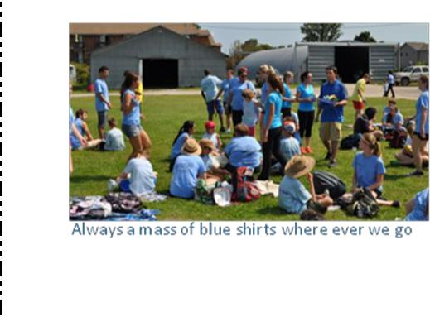
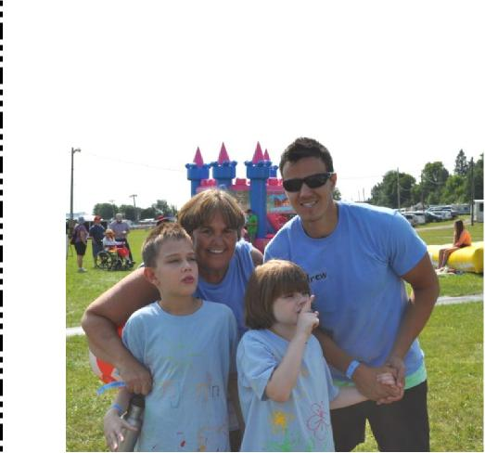
"HOW DO THEY DO IT?"
CONSTRUCTING CAMP KALEIDOSCOPE!
Children at Risk’s Summer Day Camp, Camp Kaleidoscope, is a specialty Camp where the Camp fits to the Camper - rather than the Camper having to fit into the same schedule as everyone else. After all, when every child on the Autism Spectrum is different - how can you have a summer camp that treats them all the same?
Camp Kaleidoscope's Camper application process is also different – starting with it not being done on a “first-come, first-serve” basis, so we thought we would explain how it works.
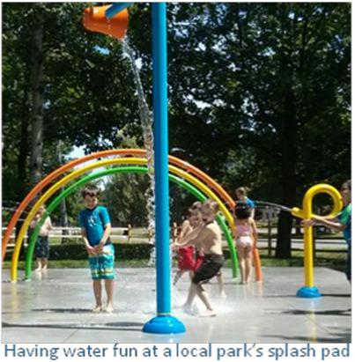
New applicants are asked to fill out a lengthy form so as we can assess the functionality of the Camper and the level of support required for the Camper. The Intake process allows the family to discuss their child in further detail as well as the opportunity to meet the child in person. The more information we can receive on a Camper, the better we can meet their needs!
This year, the Long Form was given an overhaul from 2014 - so returning Campers were also asked to complete the Form - as there were many new questions. This allowed an update of all of our Camper’s information – as some have been with us for many years - and much can change in a year!

All current Member Families received the Camper Application in our March quarterly newsletter, followed up by an email to our Group Member Listing, as well as being posted on our Website and other groups like the Autism Support List. This year, Families that had Campers attend in 2014 (or our Saturday Fun Club & Fun Nights) had until May 15th to submit their application form – indicating the total number of weeks they were requesting, as well as their priority for the 5 weeks
Children at Risk Issue 71 Page 13
available. Camper
applications for those attending for the first time were asked to submit by May 1st. This was to allow for Intake meetings to be scheduled so as to have all the relevant information on the Camper by the 15th May.
All the Applications (emails, faxes and hardcopies) were collected and on May 15th the Camper Allocation Team met to begin the scheduling. With the high number of Campers per Camp Week (and the available space with again using a high school instead of elementary) - it was deemed that for 2015 there was a need for 10 groups organized by age and functionality. This was one more than last year, as many of the Campers had become teens and needed to move up.

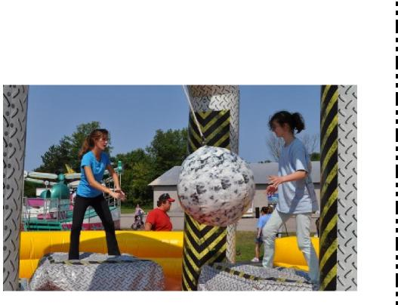
This created a number too large for the one room that had existed in 2014 for the higher energy Teens. Also this allowed for 2014 Kids age range to move up to Mid-Age range Groups, creating room for new, younger Campers. Each Group has a limit as to how many Campers can attend each week and the Camp has an overall limit as to how many Campers in total could attend each week to make it manageable and safe. There is, as well, a total number of Camp slots for 2015 as dictated by the Budget. We do our very best - but the money only goes so far!
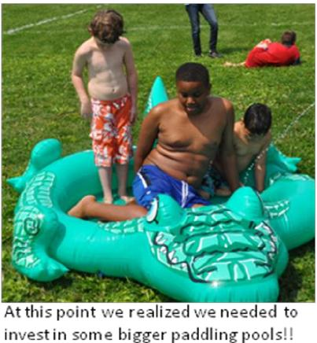
Each Camper was designated a Group. They were then given the number of weeks requested as closely as possible to the preference of which weeks and this was entered into an Excel spreadsheet. Careful attention was also given to who was in each group per week to allow for compatibility and friendships whether hopefully new or for returning friends. A few phone calls were made clarifying preferences and seeing whether there was the ability to change weeks if we deemed others would be better.
Ultimately - every family got what they asked for and mostly for their first preferences. With Campers in the school summer program, IBI program and scheduling holidays – it is indeed a juggling act to balance out each Week of our 5 Weeks and the total number of Campers for the summer!
Once the spreadsheet was completed it was then possible to see if there was space for those new applications received after the May 1st and 15th deadlines. However, late applications could only be offered select spots where the Camper fit the Group and there was still space. Once everything was taken into consideration- we had a "Master" list.
Children at Risk Issue 71 Page 14
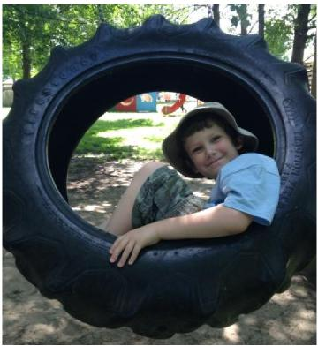
This "Master" list was returned to the Children at Risk office – Families were contacted to confirm the weeks and arrange payment to secure the Camp weeks. From past years' experience, this is where everything can change. Family summer plans change, their child either is turned down or accepted for other support – so they need to change the number of weeks or the preference of weeks. This year – this was your one opportunity to make changes – but once payment was received, we are now charging an administration charge to reflect costs such as credit card fees and the time involved in rescheduling.
We try to help Families understand that signing up for Camp is not like signing up for swimming lessons – much time, thought and effort is put into making sure your Camper has the best fit in order to have the best summer camp experience possible!

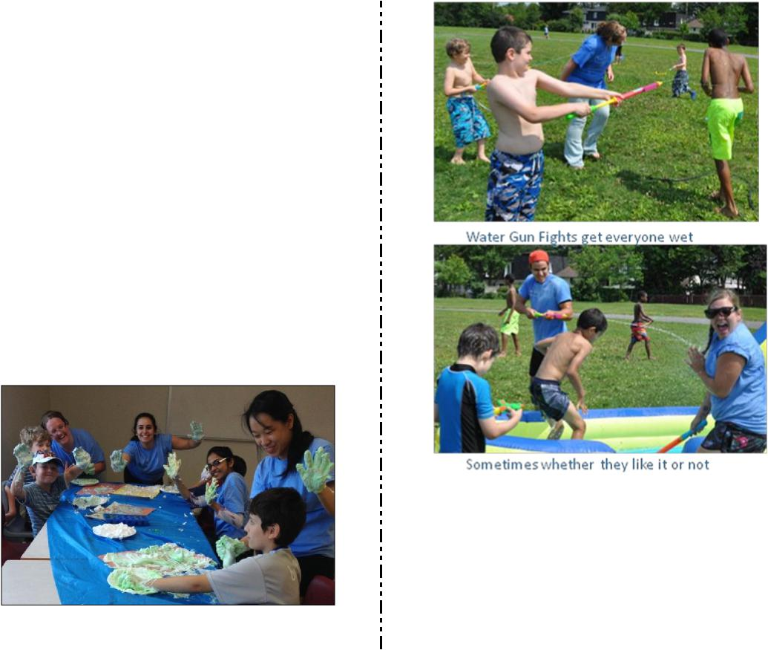
Whilst the Camper application process has been in full swing - so has the Camp Counsellor Applications! Children at Risk has been very fortunate over the last 5 years to have had wonderful Camp staff. With Camp Kaleidoscope employment being less than 6 weeks each summer, we are a good employment opportunity for students in a wide range of subjects related to youth to expanded their studies with hands on experience. But then upon graduation - either did not stay on in the Ottawa area or took employment that was not with a school board (so now were not available during the 5 weeks of Camp). We have, however, been very fortunate to retain some staff from year to year - still having some staff from years 2011 and 2012. We have had staff move away from the City, return and then apply back to work at Camp Kaleidoscope again.

Children at Risk’s Saturday Fun Club and Family Fun Nights respite Programs in the Fall and Winter have allowed some staff to stay with us all year round. Add to that March Break Camp and we have many opportunities for hiring new staff that can gain valuable experience and hit the ground running for summer camp. Since March Break, we have been inviting qualified, police-checked candidate counsellors to Saturday Fun Club for those keen to be Camp Kaleidoscope Camp Counsellors – allowing some hands-on experiences and an opportunity for CAR to profile them in action!
As with Campers, Counsellors can look different on paper than in person. Some just come for the one session but many enjoy the program and stay on for the remaining sessions. This extra influx of staff has also allowed us to grow the Saturday Fun Club program from 20+ Clubbers per session in the Fall to 40+ Clubbers per session for our remaining few in May and June. New staff are given the opportunity to work in the different age and functionality groups so that they know where they are most comfortable. Some that thought they only wanted to work with the younger kids are actually more comfortable with the mid age range. Some found the younger ones more challenging than they thought - but the Teenagers not as scary as they first imagined!
Returning Camp Counsellors and those who had worked the Fun Club programs who were available for all 5 weeks were given confirmation once we had the "Master" list that they were hired for all 5 weeks so we did not lose them to other Programs! Those that are only available for 1 to 4 weeks must wait for confirmation until the parents have made their changes. We not only fit the Camp to the Campers – we fit the Camp Counsellors to the Campers – so we cannot hire someone who then has no Camper to work with.
Children at Risk Issue 71 Page 15

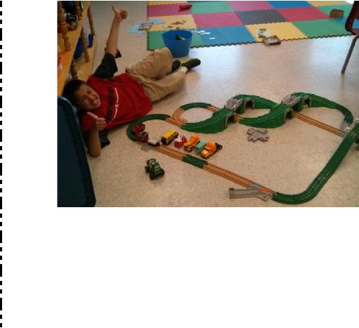
Those with odd weeks of availability are of a bonus to us as it also means we can hire according to the weeks in higher demand.

The "Master" List then turns into a "Staff Allocation" List where campers are matched up with Camp Counsellors who have the best level of experience to give them the most supportive and fun summer camp experience. Once every Camper has a Counsellor and every Counsellor matches with the weeks they are available it is then time to confirm staff weeks, organize pay scales and send out contracts of hire – WHEW!
Children at Risk Issue 71 Page 16
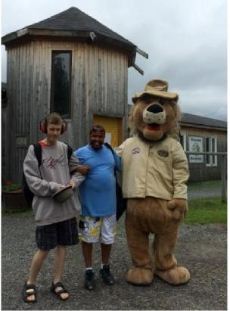
10 Groups equals 10 Group Leaders. This year we have three returning group leaders, three who are being promoted from last year's counsellors and four whom are new but three of which were Leaders for March Break or at subsequent Saturday Fun Clubs. Each Group also has a Group 2nd that can step into run the group should the Group Leader be unavailable for any reason.
These individuals are eager to get their hands on the "Master" List, start reading up on their Groups Campers profiles and plan activities and trips accordingly. Group Leader planning dates have been scheduled so that although there are 10 Groups - there is ultimately one Camp where groups come together for activities regardless of age, the facilities such as kitchen, gym and trampolines are shared equally and (for example) those stronger at planning Mad Science can help those who maybe better at coming up with craft activities.
There is a lot going on before the end of June and then we get access to Lester B Pearson high school and it is all systems go to turn classrooms into Club Rooms for each Group. Have Staff training and introduce each Groups Camp Counsellors to their team mates and discuss the campers and the schedule of activities and responsibilities. Before we know it – it will be July 13th and the Campers arrive!!!
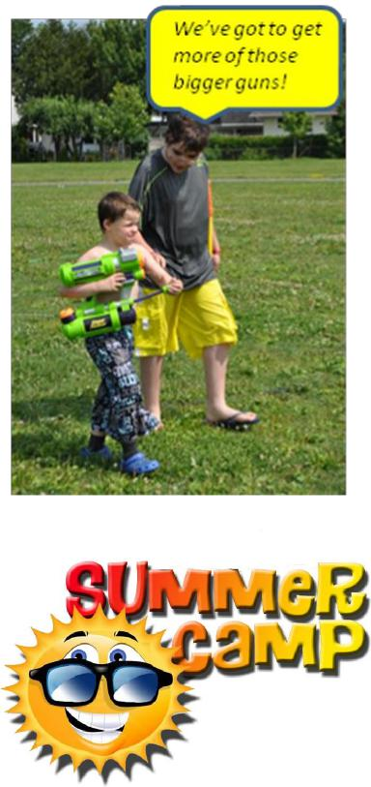

If you have a child with autism, then you know that there are good days and bad days, grateful days and resentful days. You have days where autism takes a back seat and days where autism is not only sitting up front with you, it’s in the driver’s seat.
12 Great Things to Say to Parents of Kids With Autism By Kathy Hooves
Children at Risk Issue 71 Page 17
Just like every child is affected differently by an autism diagnosis, each parent is also affected differently. A comment that I believe is kind and encouraging, another parent may see as rude and condescending. Needless to say, I can’t give you an exhaustive list since every situation is different, however, I have come up with a few things people have said to me over the years that clearly left a mark and not a scar. So, this is a list of things TO say to a parent loving a child with autism that made me smile and want to hug them rather than hit them or scratch their eyes out.
The one thing to remember, regardless of the child or the parent, is to always be accepting, be aware and be kind.
- “Wow! I can’t believe how far he has come!”
Even if the distance from where he was to where he is seems miniscule to you, chances are it is a huge, expansive distance to my son and me. Commenting on progress is a beautiful thing to say, but only if you really see progress or change. We mothers are like dogs; we can smell your fear in an off-handed, don’t-know-what-else-to-say remark. So if you do believe it, then say it. And be prepared to be hugged.
- “He is so good at... [insert anything here].”
Whether it’s a perfect Jim Carrey imitation, how long he can sit watching the same episode of “Thomas the Tank Engine” and recite every word perfectly, or his ability to memorize all the details of every earthquake in California’s history, point it out. Point out the positives. See the positives. We see it. We know it. We love when you do, too.
- “My friend’s, sister’s, cousin’s, great aunt twice removed’s son has autism and he is in college now.” Yeah, we know that your friend’s, sister’s, cousin’s, great aunt twice removed’s son is not our child, and we
know that autism is a spectrum of strengths and struggles, but, hearing success, hearing good news and having
you share that in a kind, accepting and compassionate way, makes us love you, even if we don’t know you. I
hope you like hugging strangers, because this may get you an even bigger hug than #1.
- “Is there anything I can do to help?”
Asking this question in the middle of aisle six in the busy, loud grocery store where our child is currently having a huge sensory meltdown as we try to calm him down and discreetly scooch the glass shards from the spaghetti jar that just missed your head under our cart, rather than staring at what you believe may be an
“undisciplined child” having a temper tantrum, may possibly make you the hero in a blog story that goes viral
on social media three hours after you get home from the grocery store.
We know people are staring. We know people are judging. We know people don’t get it. That’s why those eight
simple words from just one person are beautiful. Oh, and sorry about the spaghetti sauce on your new shoes.
- “He feels so much, doesn’t he?”
This is a kind, compassionate and understanding way to say that when you see our child crying easily, melting down regularly, and being terribly inflexible, you are letting us know that you recognize that there may be more than meets the eye and that our child is not bad, and neither are we.

- “He is fascinating.”
12 Great Things to Say to Parents of Kids With Autism (Cont'd) By Kathy Hooves
Children at Risk Issue 71 Page 18
Not weird, not odd, not quirky. The way his mind works is fascinating and often has me in awe and wonder. I love knowing that you see his mind as extraordinary and not as something that is broken and needs to be “fixed.”
- “He really loves you.”
Yes he does. There is such a misconception that children with autism don’t feel love, that their emotions are too bogged down by autism to “feel,” but, believe me, they feel love, they know love, they give love. And on days when it’s hard, on days where we have lost our patience, raised our voice and dried countless tears, we don’t feel very loveable, so it’s great when others see and feel that love, too. We know that our child loves us like no other and although that love may look “different,” it is never to be trivialized or minimized.
- “I wonder what he is thinking?”
O.M.G. If you only know how many times a day I have wondered the VERY same thing. “If only I could get inside his head,” “If I only knew what he was feeling,” “If only he would let me in” has crossed every parent’s mind countless times. Knowing that you take the time to wonder, too, well, you have just gone up higher in rank on the Favorites list on my iPhone.
- “What is autism and why do they call it a spectrum?”
Yes, maybe we are tired of talking about The A Word, maybe we want people to see past autism and just see our child, but, we will never turn down an opportunity to educate someone about our child and debunk the “He doesn’t act like ‘Rain Man'” myth. So please, ask away.
- “He has taught me so much!”
These kids see the world differently and if you take the time to get to know them, really get to know them, you will open your mind and your heart to their world and you will be better for it.
- “I brought wine.”
Even though you might not fully understand what loving a child with autism is like, the fact that you are here, on our doorstep, holding a bottle of wine and trying to understand, well, there are no words to express our gratitude. We love that you feel like we are in this together, so grab two glasses while I get the bottle opener.
- “I have Velveeta Shells and Cheese (or whatever the one and only type of food is that child will eat).” You win. Game over.
When trying to decide what you should say, keep in mind that these children and adults with autism may have severe language deficits and they may not be able to say a word, but that does not mean they aren’t communicating with you. Take their lead. Maybe no words are necessary. Maybe you don’t have to SAY anything. Maybe it’s just a kind smile, a door held, making eye contact with us or a kind “hello” to our child.
However, if we initiate the conversation, if we say the words, “My son has autism,” just give us a knowing look, a kind smile and ask, “How is he doing?” We may say “fine” or we may break into a 10-minute long discussion about how far he has come and how far we know he will go. Whichever it is, trust me when I say, we will always remember that you asked.
From: http://themighty.com

ADVERTISING
Disclaimer: This Newsletter is for informational purposes only. Children at Risk does not support, endorse or recommend any method, treatment, product, remedial center, program or person for people with autism or autism related conditions.

New Patients Welcome
Children at Risk 2015 Raffle Ticket Sample
Children at Risk Issue 71 Page 19

OTTAWA AUTISM COMMUNITY
Children at Risk Issue 71 Page 20
ANNUAL FAMILY PICNIC
Sunday, June 14, 2015
12 Noon-3 PM
Brewer Park
Brewer Park (Seneca St. off Sunnyside) is a sprinkler water park, so bring your suits and get wet! The Annual Family Picnic is a great time to celebrate the start of summer, see old friends, meet new friends and frolic in the park. Below is a list of planned activities. Some items and activities, like the food, are at a low cost or you can bring your own picnic lunch! Hope to see you there!!
Activities & Features:
B.B.Q. HAMBURGERS, HOT DOGS, DRINKS, CHIPS, COOKIE DECORATING,
FISH POND, BALLOONS, COTTON CANDY & SNOW CONES (low cost)
*FREE*: WATERMELON, BUBBLE PLAY,
OBSTACAL COURSE & MOON BOUNCE INFLATABLES
2:00 PM –20th ANNUAL RAFFLE DRAW
2:30 PM - WATER BALLOON TOSS (**PRIZES**)
** IN ADDITION, WE WILL BE ENTERTAINED BY TUNIS SHRINE KLOWNS! BACK AGAIN – Heather Unhola from “A Little Bit of Bling” Face Painting & Body Art BBQ courtesy of The Gathering Church
For more info, call 613-741-8255 or email car@childrenatrisk.ca

